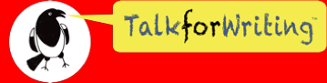
Doors
(the world of possibility)
Year 6 Workbook

Introduction
Have you ever looked at a door and wondered what might be on the other side? Where may it lead? What may be hiding within? At first glance, a door is just a piece of wood, glass or metal that is opened and closed so that people can get in and out of a room, a vehicle or a space. But in the hands of a writer, a door represents a world of possibility, a world where things are not only hidden but often closed off and restricted. Together, through poetry, text games and narrative, we shall explore the potential that a door offers to you, the writer.
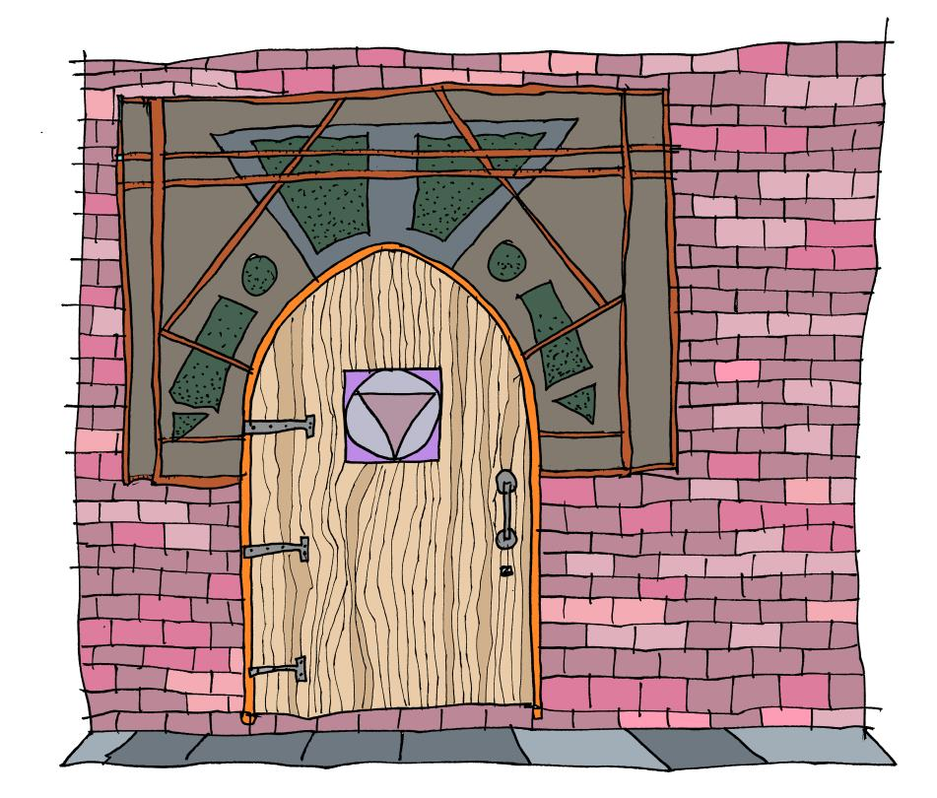

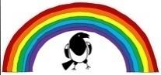
© Talk for Writing
Please date your work:
L.O Writing creatively
Activity 1: The world we live in
As I write this, the world is in lockdown, shut behind doors for our own safety and the safety of everyone else. Covid-19 has closed schools, closed shops and temporarily closed some of the things we take for granted, like playing in the park with our friends.
★ Make a list of all the things that you miss doing. You may like to think about some of the following categories:
- seeing family - seeing friends - day to day things
- playing sports - exploring your interests - places you love to visit
Throughout these sessions, you may like to use these personal reflections to inspire and influence your writing.

Please date your work
L.O Writing creatively
Activity 2: I opened the magical door and saw ...
This is an idea inspired by Kit Wright’s poem ‘The Magic Box’ (you could search for this on the internet to read his poem). In the poem, Kit imagines what may be contained inside a magical box. We can use this idea to connect to what could be behind the magical door.
★ Before you begin, brainstorm a list of ideas for what might be behind the door. Let your imagination run wild as there is no wrong answer.
★Once you have your list, have a go at writing a poem, using the repeating opener: I opened the magical door and saw ...
Here’s an example to help you get going:
I opened the magical door and saw shadows dancing.
I opened the magical door and saw a rainbow leading to another world.
I opened the magical door and saw people crying.
I opened the magical door and saw a magical fairground flooded in lights.

© Talk for Writing

